**DevOps Balachandran K K**

**22ISR005**

**Task 3**

Create a Kubernetes deployment in Minikube using kubectl, expose it as a service, and run Docker image to serve an HTML website.

1. Installing and starting the Minikube.

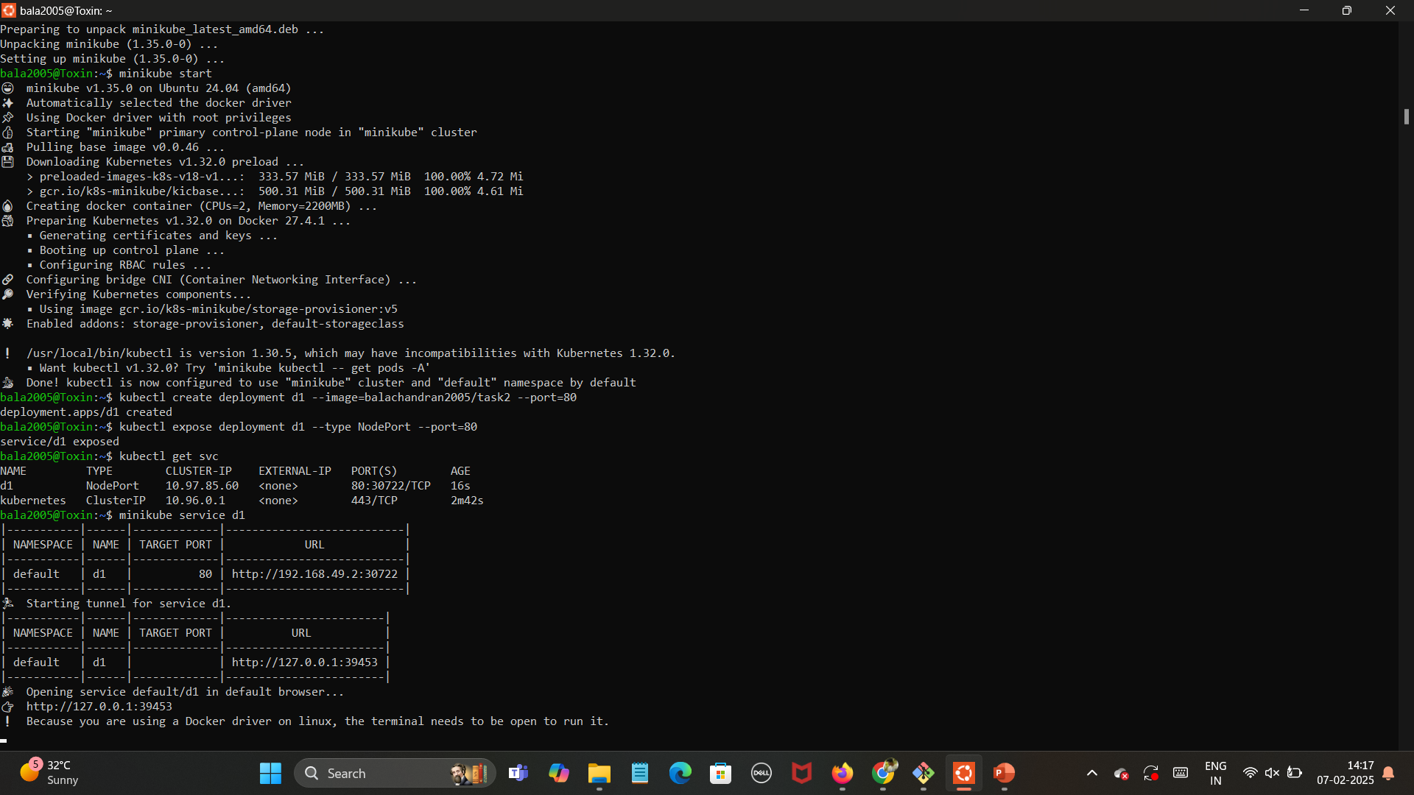

1. Creating a Deployment d1 and exposing it.



1. Verifying whether the deployment is created.



1. Starting the tunnel and running it.



1. Final output of the URL <http://127.0.0.1:39453>.

